SQL Test Paper

The tools used for this assignment: Oracle Apex online workspace for compiling and running of scripts and notepad++ for writing the scripts.

Assumptions:

**OUTPUT**

1. 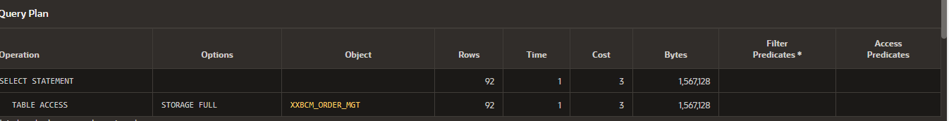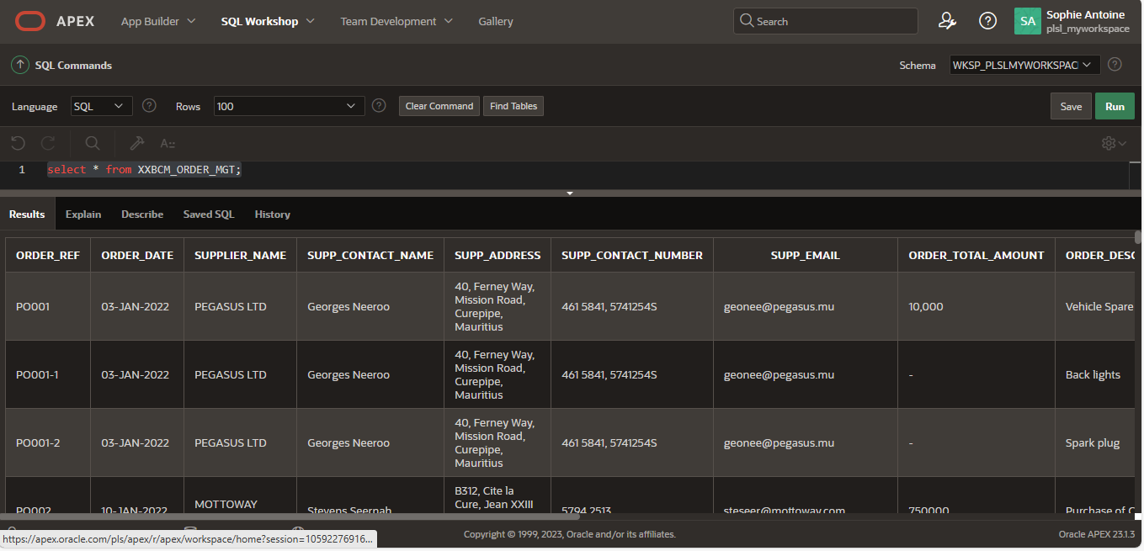Create the “XXBCM_ORDER_MGT" table using the script - DB_Prequisite.sql.

1. Based on the data provided implement a database schema with necessary tables, columns, data types and constraints. Create your tables in the database with appropriate naming convention. The tables should be appropriately normalized.

TABLE INVOICE

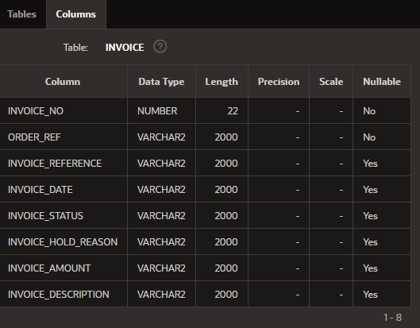

TABLE ORDERS

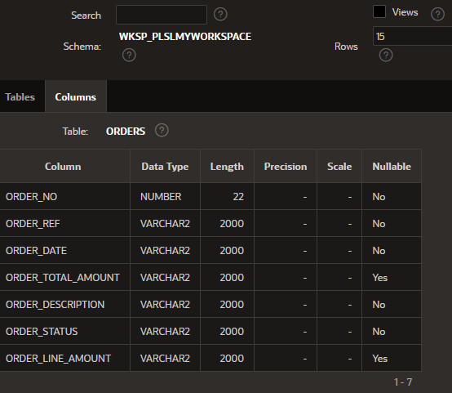

TABLE SUPPLIER

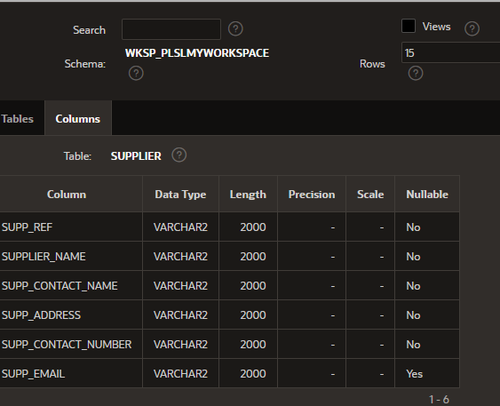

1. Develop a SQL procedure to trigger a migration process that will extract information from table "XXBCM_ORDER_MGT" and load them in tables that you created with proper data format.

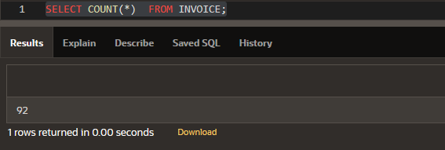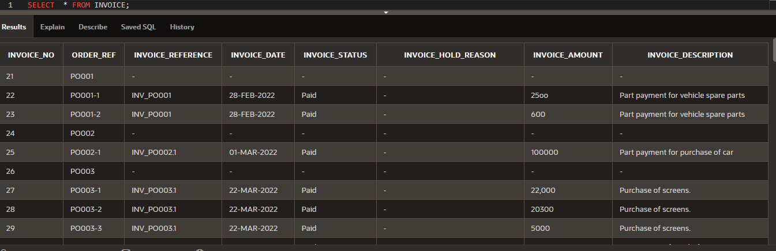TABLE INVOICE

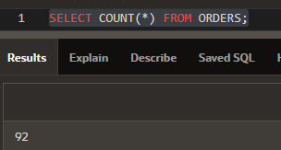TABLE ORDERS

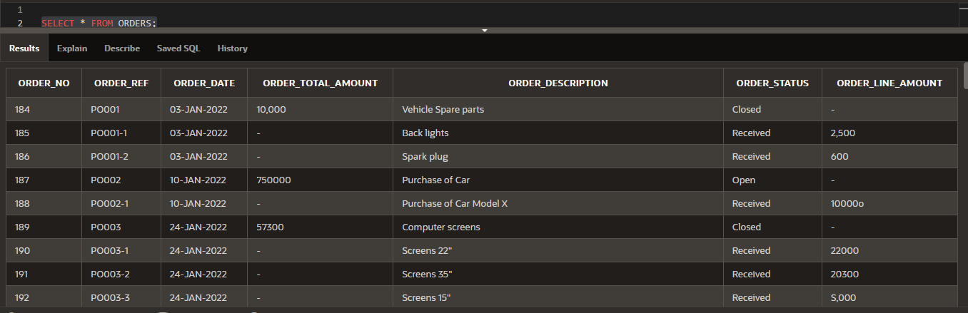

TABLE SUPPLIER

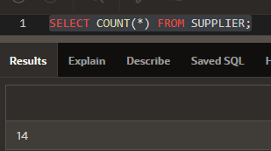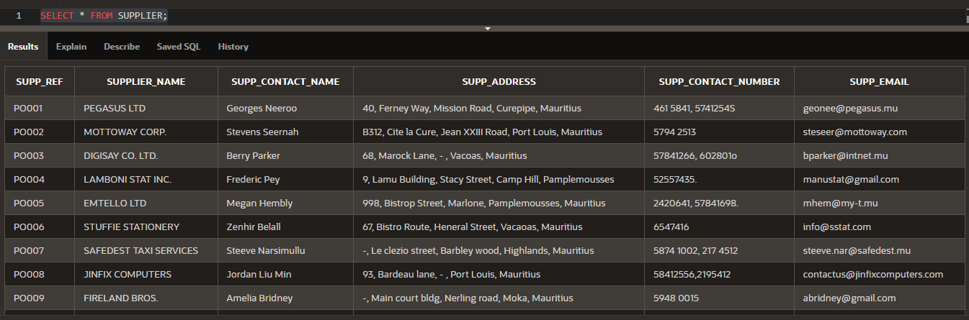

1. The owner wishes to have a report displaying a summary of Orders with their corresponding list of distinct invoices and their total amount to be able to reconcile his orders and payments. The report shall contain the details as per table below ordered by latest Order Date on top. Implement a Stored Procedure or Function to return the required information.

